**Name**: Hao-Tien Cheng

**Adapted Game**: *Jump N’ Duck*

**Source**: *Phineas and Ferb*, Episode 58 - “Gaming the System” (2009) [[YouTube link](https://www.youtube.com/watch?v=zr_r2duvxic)]

**Design Specifications**:

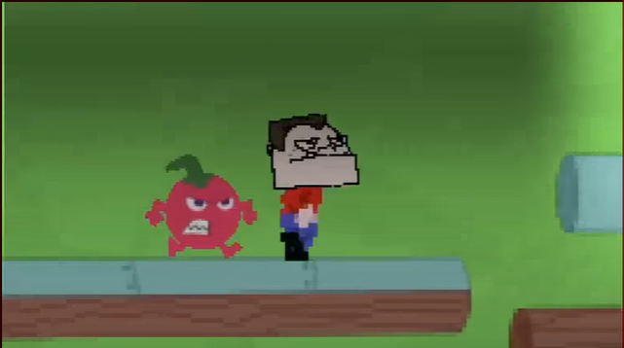

Based on the brief TV Show appearance , it looks like *Jump N’ Duck* is a 2D, side-scrolling platformer in an arcade game console. The player controls a character (Phineas, Buford, or Candace) who can jump and duck to get over obstacles and maybe attack with a hair dryer.

The gameplay is to control a character to dodge the upcoming enemies (angry fruits), jump to different platforms, and maybe shoot the enemies. There is a count down saying “3, 2, 1, GO!” before the game starts. The screen is basically in a green background but may be able to change by getting to another scene.

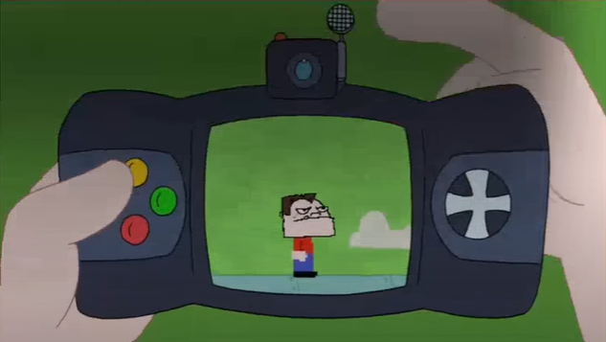

The screenshot shows what the game console looks like. There should be up, down, left, right keys and at least a shot key.

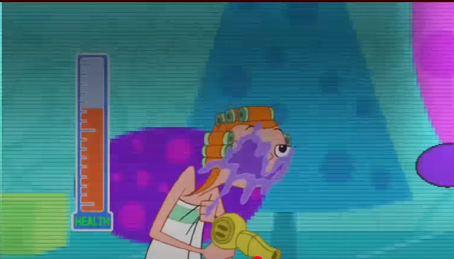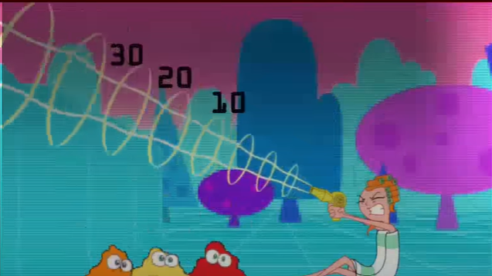

In the screenshots above, we can see there’s a health bar, which decreases when getting hit but can be regenerated by killing the enemies. Also the character gains points by defeating enemies.

The scrolling in the game seems not to be necessary. Defeating different types of enemies may gain different amounts of points and the goal of the game is not specified in the TV Show.

My adaptation will implement:

* The title, and the menu scene for the player to choose characters.
* A scene with the character jumping, ducking, or shooting, a lot of collideable platforms, and several different types of fruit enemies which will chase the character.
* The camera will follow the character as it moves.
* The character can try to get higher points by eliminating the enemies, and the health will drop if being hit. GameOver if the health drops to zero.
* A GameOver scene shows the score and lets the player choose to restart or go back the the menu scene.
* Probably a credit scene which can be branched to in the menu scene.

If I have additional time, I will implement:

* More screen animation effects
* Camera zoom in or zoom out effects if necessary
* More stages with higher difficulty

**Assets**:

* Pixel typeface for menu, high score, credits, and in-game score text
* Characters with moving, jumping, ducking, and shooting animations
* Fruit enemie sprites with animations
* Platforms
* Cloud sprites
* Grill sprite
* Tilemap
* Particle animation for enemy elimination
* Sound effects for game start, jumping, ducking,shooting, enemy dying, and game over
* Background music

If I have additional time,I will also need:

* A custom tilemap and tiles for new stages
* More sound effects for additional animations

**Alterations**:

In the TV Shows, there is a scene that seems like Candace can destroy the trees or walls (obstacles) with the hair dryer (laser gun). Also there are some portals or mechanics that can maybe carry the character across the gap. I will try to implement these in my game.

I will also need to extend the level beyond the brief section seen and create custom background music. All visual assets should be replicable using a pixel art editor (Aseprite or Piskell).